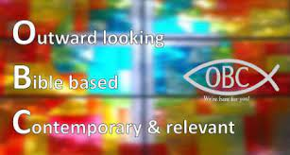

Dear Parent/Carer

The Youth Ministry team here at Orpington Baptist Church are delighted to announce that our summer festival trip will be going ahead in August.
From 9th - 14th August we will be joining with other young Christians from all over the country to attend Satellites festival, a programme put together by Youthscape.
We believe that these gathering can really impact young people’s lives. We see hundreds of young people give their life to Jesus over the week and we couldn’t encourage it enough.
The price below includes a ticket to 5 days of amazing teaching and worship, transport to and from Orpington Baptist Church and all food and drink too. The only extra money your young person will need is spending money for stalls/merchandise etc.
Dates: Tuesday 9th August 2022 – Sunday 14th August 2022
Venue: Peterborough arena and showground, PE2 6XE
Included:
- Camping accommodation (not including sleeping bag/camp bed)
- Ticket to the 5-day event
- Transport to and from OBC
- All food and drink
Price: £200
£105 as the cost of entry must be paid as a deposit to secure your place, with the remaining £95 being paid before July 31st.
If you would like your child to attend please fill in the attached form and return it asap.
The deposit can be made by either cheque, cash or BACS (banking details provided upon request).

If you have any further questions then please email or call one of the team who will be happy to help you further.

God Bless you,
Michael Lynds – Youth Worker
07722 346032 – youthministry@orpingtonbaptist.org.uk
Phil Dyal – Minister-in-Training
07817 986830 – phildyalgig@gmail.com

